Task 1: RAM Generation Comparison Table

Feature | DDR3 | DDR4 | DDR5
Speeds | 800 – 2133 MT/s | 2133 – 3200 MT/s | 4800 – 8400+ MT/s
Voltage | 1.5 V (1.35 V for DDR3L) | 1.2 V | 1.1 V
Module Architecture | Single 64-bit channel | Single 64-bit channel | Dual 32-bit subchannels per DIMM
Power Management | Controlled by motherboard | Controlled by motherboard | On-DIMM PMIC (Power Management IC)
Typical Use Cases | Legacy systems, older office PCs, budget home servers | Mainstream gaming, daily office/school laptops, standard workstations | High-end gaming, 4K/8K video editing, AI workflows, modern servers

Task 2: Reinstall the RAM
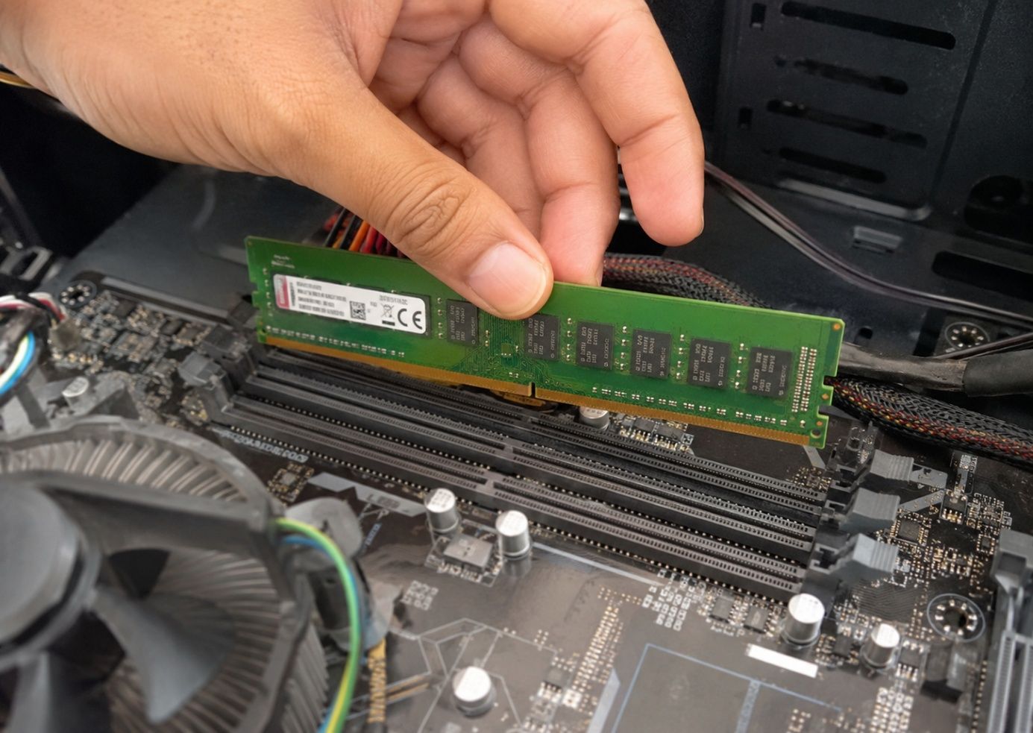

Task 3: HDD vs. SATA SSD vs. NVMe Storage Differences & Use Cases

- Key Differences:
  - Architecture & Mechanism: HDDs use mechanical spinning magnetic platters and moving read/write heads; SATA SSDs and NVMe SSDs use silent, solid-state NAND flash memory with no moving parts.
  - Speed & Latency: HDDs transfer data at 80–160 MB/s with high access latency (~10–15 ms); SATA SSDs max out around 500–550 MB/s; NVMe PCIe drives reach 3,500–7,500+ MB/s with near-zero latency (<0.1 ms).
  - Interface & Form Factor: HDDs use bulky 2.5-inch or 3.5-inch SATA enclosures; SATA SSDs use 2.5-inch drives or SATA M.2; NVMe drives connect directly to high-speed PCIe lanes via compact M.2 (2280) slots.
- Beneficial Daily Apps & Use Cases:
  - HDD Use Case (Mass Data Archiving): Storing large media libraries, long-term backups, or offline surveillance footage (e.g., local backup storage).
  - SATA SSD Use Case (General Productivity & OS): Running standard operating systems and everyday apps (e.g., Google Chrome, Microsoft 365 / Office) where high NVMe throughput is not strictly necessary.
  - NVMe SSD Use Case (Heavy Data Streaming & Loading): High-end video editing and timeline scrubbing (e.g., Adobe Premiere Pro / DaVinci Resolve) or modern AAA gaming with direct asset streaming.

